Application Opened
Main content

Chapter Introduction
Chapter 1 is the first of three chapters in the systems planning phase. This chapter explains the role of information technology in today’s dynamic business environment. This chapter describes the development of information systems, systems analysis and design concepts, and various systems development methods. This chapter also summarizes the role of the information technology department and its people in the enterprise.
The chapter includes three “Case in Point” discussion questions to help contextualize the concepts described in the text. The “Question of Ethics” invites examination of the ACM’s code of ethics and those of a developing systems analyst.

Learning Objectives
When you finish this chapter, you should be able to:
- Describe the impact of information technology on society
- Describe the five main components of an information system
- Explain Internet business strategies and relationships, including B2C and B2B
- Explain how to use business profiles and models
- Understand the seven types of information systems used in business
- Describe the types of information the four classes of users need
- Distinguish among structured analysis, object-oriented analysis, and agile systems development methods
- List the tools that enable the systems analyst to develop, manage, and maintain large-scale information systems
- Explain the seven main functions of the information technology department
- Describe the roles and responsibilities of a systems analyst within the enterprise
Go to pg.
help
Application Opened
Main content

1.1Information Technology
Information technology (IT) refers to the combination of hardware, software, and services that people use to manage, communicate, and share information. Companies use information as a way to increase productivity, deliver quality products and services, maintain customer loyalty, and make sound decisions. In a global economy with intense competition, information technology can mean the difference between success and failure.
More than ever, business success depends on information technology. IT is driving a new digital economy, where advances in hardware, software, and connectivity can provide enormous benefits to businesses and individuals. Although economic trends affect IT spending levels, most companies give IT budgets a high priority, in good times or bad. The reason is simple: during periods of growth, companies cannot afford to lag behind the IT curve. Conversely, when the economy slows down, firms often use IT to reduce operating costs and improve efficiency.
Information technology also has profound influence on modern life. Although fictitious, the headlines in Figure 1-1 offer dramatic examples of how information technology issues such as data privacy, mobile devices, and social media affects our society. We live in a world where we can be traced, analyzed, and surveilled without our knowledge. This raises many important questions, such as how to secure personal data while still providing useful functionality and business value.
Figure 1-1
These headlines illustrate the enormous impact of information technology on our lives.
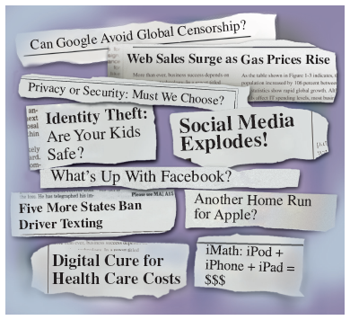
The following sections provide a sense of IT history, an overview of systems analysis and design, and a description of the systems analyst’s role.
Go to pg.
help
Application Opened
Main content

1.1.1The Changing Nature of Information Technology
The history of IT is a fascinating study of human progress and achievement. We are dazzled by the latest and greatest technology, just as our parents and grandparents were astonished by the arrival of television, space flight, and personal computing. It is important for IT professionals, who live and work in this exciting world, to realize that each technology advance is part of a long-term process that often brings dramatic change but never really ends. The story of IBM is a good example.
As its name suggests, International Business Machines was a major supplier of office equipment and typewriters long before the modern computer era. Herman Hollerith, who invented a card that identified characters by the location of punched holes, founded IBM’s predecessor company in 1896. A deck of hundreds or even thousands of these cards could store data that was easily sorted, queried, and printed by machines. This system sounds archaic now, but punch card technology was a huge advance that revolutionized the business world and was in use into the 1960s and beyond.
Today, IBM is a globe-spanning company with several hundred thousand employees. It has succeeded in part by constantly adapting to its changing business environment. For example, while it was once known primarily as a hardware company, today IBM makes a significant part of its revenue from software and services. It also invests in its people and tries to hire the best talent available. The result is that IBM has more patents and more Noble Prize winners than any other IT company in history.
Go to pg.
help
Application Opened
Main content

1.1.2Systems Analysis and Design
Systems analysis and design is a step-by-step process for developing high-quality information systems. An information system combines technology, people, and data to provide support for business functions such as order processing, inventory control, human resources, accounting, and many more. Some information systems handle routine day-to-day tasks, while others can help managers make better decisions, spot marketplace trends, and reveal patterns that might be hidden in stored data.
Talented people, including a mix of managers, users, network administrators, web designers, programmers, and systems analysts, typically develop information systems. Capable IT professionals like these are always in demand, even in a slow economy. For example, notice how many positions related to information technology and information systems are available in the Melbourne, Florida area, as shown on Monster.com’s job search website in Figure 1-2.
Figure 1-2
Monster.com is an example of an online job search website that IT professionals can use.
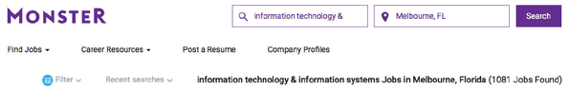
Source: Monster.com
Go to pg.
help
Application Opened
Main content

1.1.3What Does a Systems Analyst Do?
A systems analyst is a valued member of the IT department team who helps plan, develop, and maintain information systems. Analysts must be excellent communicators with strong analytical and critical thinking skills. Because systems analysts transform business requirements into IT projects, they must be business-savvy as well as technically competent and be equally comfortable with managers and programmers, who sometimes have different points of view.
Most companies assign systems analysts to the IT department, but analysts can also report to a specific user area such as marketing, sales, or accounting. As a member of a functional team, an analyst is better able to understand the needs of that group and how IT supports the department’s mission. Smaller companies often use consultants to perform systems analysis work on an as-needed basis.
On any given day, an analyst might be asked to document business processes, test hardware and software packages, design input screens, train users, and plan e-commerce websites. A systems analyst may occasionally manage IT projects, including tasks, resources, schedules, and costs. To keep managers and users informed, the analyst conducts meetings, delivers presentations, and writes memos, reports, and documentation.
Section 1.9 lists typical skills and education requirements, certifications, career opportunities, and the possible impact of future IT trends for systems analysts.
Go to pg.
help
Application Opened
Main content

1.2Information Systems
A system is a set of related components that produces specific results. For example, specialized systems route Internet traffic, manufacture microchips, and control complex entities like the Hubble telescope, which took the amazing image shown in Figure 1-3. A mission-critical system is one that is vital to a company’s operations. An order processing system, for example, is mission-critical because the company cannot do business without it.
Figure 1-3
Consider the amazing technology that enabled the Hubble telescope to capture this image.

Source: Courtesy of the Hubble Heritage Team (AURA/STScI/NASA)
Every system requires input data. For example, a computer receives data when a key is pressed or when a menu command is selected. In an information system, data consists of basic facts that are the system’s raw material. Information is data that has been transformed into output that is valuable to users.
An information system has five key components, as shown in Figure 1-4: hardware, software, data, processes, and people.
Figure 1-4
An information system needs these components.
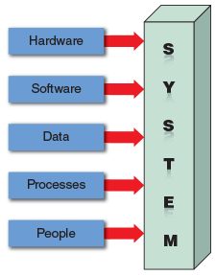
Go to pg.
help
Application Opened
Main content

1.2.1Hardware
Hardware consists of everything in the physical layer of the information system. For example, hardware can include servers, workstations, networks, telecommunications equipment, fiber-optic cables, mobile devices, scanners, digital capture devices, and other technology-based infrastructure. A large concentration of networked computers working together is called a data center. As new technologies emerge, manufacturers race to market the innovations and reap the rewards.
Hardware purchasers today face a wide array of technology choices and decisions. In 1965, Gordon Moore, a cofounder of Intel, predicted that the number of transistors on an integrated circuit chip would double about every 24 months. His concept, called Moore’s law, has remained valid for over 50 years. Fortunately, as hardware became more powerful, it also became much less expensive. Large businesses with thousands or millions of sales transactions require company-wide information systems and powerful servers, which are often now in the cloud, such as those shown in Figure 1-5.
Figure 1-5
Cloud computing provides the enormous storage and speed that modern IT systems need.
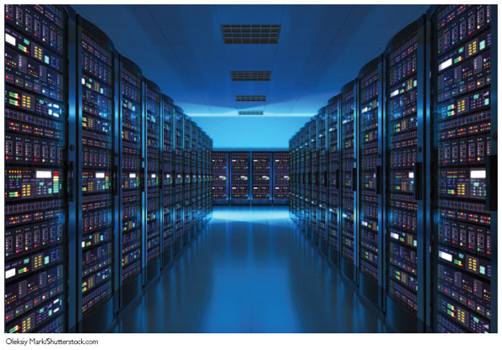
Oleksiy Mark/ Shutterstock.com
Go to pg.
help
Application Opened
Main content

1.2.2Software
Software refers to the programs that control the hardware and produce the desired information or results. Software consists of system software and application software.
System software manages the hardware components, which can include a single computer or a global network with many thousands of clients. Either the hardware manufacturer supplies the system software or a company purchases it from a vendor. Examples of system software include the operating system, security software that protects the computer from intrusion, device drivers that communicate with hardware such as printers, and utility programs that handle specific tasks such as data backup and disk management. System software also controls the flow of data, provides data security, and manages network operations. In today’s interconnected business world, network software is vitally important.
Application software consists of programs that support day-to-day business functions and provide users with the information they need. Examples of company-wide applications, called enterprise applications, include order processing systems, payroll systems, and company communications networks. On a smaller scale, individual users can boost productivity with tools such as spreadsheets, presentation software, and database management systems.
Application software includes horizontal and vertical systems. A horizontal system is a system, such as an inventory or payroll application, that can be adapted for use in many different types of companies. A vertical system is designed to meet the unique requirements of a specific business or industry, such as an online retailer, a medical practice, or an auto dealership.
Most companies use a mix of software that is acquired at various times. When planning an information system, a company must consider how a new system will interface with older systems, which are called legacy systems. For example, a new human resources system might need to exchange data with a legacy payroll application.
Go to pg.
help
Application Opened
Main content

1.2.3Data
Data is the raw material that an information system transforms into useful information. For example, an information system using a relational database can store data in various locations, called tables. By linking the tables, the system can display the specific information that the user needs—no more and no less. Figure 1-6 shows a payroll system that stores data in four separate tables. Notice that the linked tables work together to supply 19 different data items. A user can display any or all data items and filter the data to fit defined limits. In this example, the user requested a list of employees who live in a certain city and worked more than 40 hours in the last pay period. Jane Doe’s name was the first to display.
Figure 1-6
In a typical payroll system using a relational model, data is stored in separate tables that are linked to form an overall database.
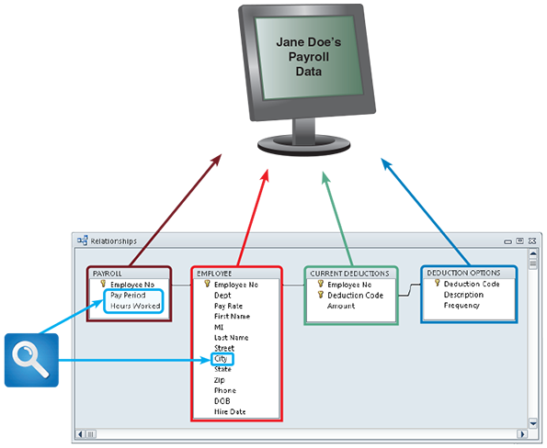
The growth of big data has given rise to new ways of storing, searching, and managing data. Traditional relational models are still used, but so-called NoSQL databases are gaining in popularity due to their ability to scale to extremely large and unstructured datasets.
Go to pg.
help
Application Opened
Main content

1.2.4Processes
Processes describe the tasks and business functions that users, managers, and IT staff members perform to achieve specific results. Processes are the building blocks of an information system because they represent actual day-to-day business operations. To build a successful information system, analysts must understand business processes and document them carefully.
Go to pg.
help
Application Opened
Main content

1.2.5People
People who have an interest in an information system are called stakeholders. Stakeholders include the management group responsible for the system, the users (sometimes called end users) inside and outside the company who will interact with the system, and IT staff members, such as systems analysts, programmers, and network administrators, who develop and support the system.
Each stakeholder group has a vital interest in the information system, but most experienced IT professionals agree that the success or failure of a system usually depends on whether it meets the needs of its users. For that reason, it is essential to understand user requirements and expectations throughout the development process.
Case in Point 1.1

Data Breaches
- A data breach occurs when a hacker gains illegal access to a system and steals personal data, such as credit card numbers or home addresses. With more of our information stored in the cloud, data breaches are becoming increasingly common. Research recent news articles about large-scale data breaches, summarize why they occurred, and suggest how they might be prevented in the future.
Go to pg.
help
Application Opened
Main content

1.3Internet Business Strategies
To design successful systems, systems analysts must understand a company’s business operations. Each situation is different. For example, a retail store, a medical practice, and a hotel chain all have unique information systems requirements. As the business world changes, systems analysts can expect to work in new kinds of companies that will require innovative IT solutions.
Business today is being shaped by three major trends: rapidly increasing globalization, technology integration for seamless information access across a wide variety of devices such as laptops and smartphones, and the rapid growth of cloud-based computing and software services. These trends are being driven by the immense power of the Internet.
Go to pg.
help
Application Opened
Main content

1.3.1The Internet Model
Internet-based commerce is called e-commerce (electronic commerce). Internet-based systems involve various hardware and software designs, but a typical model is a series of web pages that provides a user interface, which communicates with database management software and a web-based data server. On mobile devices, the user interacts with the system with an app, but the same back-end services are accessed. As Internet-based commerce continues to grow, career opportunities will expand significantly for IT professionals such as web designers, database developers, and systems analysts.
Go to pg.
help
Application Opened
Main content

1.3.2B2C (Business-to-Consumer)
Using the Internet, consumers can go online to purchase an enormous variety of products and services. This new shopping environment allows customers to do research, compare prices and features, check availability, arrange delivery, and choose payment methods in a single convenient session. Many companies, such as airlines, offer incentives for online transactions because web-based processing costs are lower than traditional methods. By making flight information available online to last-minute travelers, some airlines also offer special discounts on seats that might otherwise go unfilled.
B2C (business-to-consumer) is changing traditional business models and creating new ones. For example, a common business model is a retail store that sells a product to a customer. To carry out that same transaction on the Internet, the company must develop an online store and deal with a totally different set of marketing, advertising, and profitability issues.
Some companies have found new ways to use established business models. For example, Airbnb and VRBO have transformed the traditional hospitality service industry into a popular and successful way for individuals to rent their properties. Other retailers seek to enhance the online shopping experience by offering gift advisors, buying guides, how-to clinics, and similar features. In the e-commerce battles, the real winners are online consumers, who have more information, better choices, and the convenience of shopping at home.
Go to pg.
help
Application Opened
Main content

1.3.3B2B (Business-to-Business)
Although the business-to-consumer (B2C) sector is more familiar to retail customers, the volume of B2B (business-to-business) transactions is many times greater. Industry observers predict that B2B sales will increase sharply as more firms seek to improve efficiency and reduce costs.
Initially, electronic commerce between two companies used a data sharing arrangement called electronic data interchange (EDI). EDI enabled computer-to-computer data transfer, usually over private telecommunications lines. Firms used EDI to plan production, adjust inventory levels, or stock up on raw materials using data from another company’s information system. As B2B volume soared, company-to-company transactions migrated to the Internet, which offered standard protocols, universal availability, and low communication costs. The main advantage of the web is that it offers seamless communication between different hardware and software environments, anywhere and anytime.
Because it allows companies to reach the global marketplace, B2B is especially important to smaller suppliers and customers who need instant information about prices and availability. In an approach that resembles an open marketplace, some B2B sites invite buyers, sellers, distributors, and manufacturers to offer products, submit specifications, and transact business.
Most large firms and government agencies use supply chain management (SCM) software. A supply chain refers to all the companies who provide materials, services, and functions needed to provide a product to a customer. For example, a Sherwin-Williams customer who buys a gallon of paint is at the end of a chain that includes the raw material sources, packaging suppliers, manufacturers, transporters, warehouses, and retail stores. Because SCM is complex and dynamic, specialized software helps businesses manage inventory levels, costs, alternate suppliers, and much more.
Go to pg.
help
Application Opened
Main content

1.4Modeling Business Operations
Systems analysts use modeling to represent company operations and information needs. Modeling produces a graphical representation of a concept or process that systems developers can analyze, test, and modify. A systems analyst can describe and simplify an information system by using a set of business, data, object, network, and process models.
A business profile is an overview of a company’s mission, functions, organization, products, services, customers, suppliers, competitors, constraints, and future direction. Although much of this information is readily available, a systems analyst usually needs to do additional research and fact-finding to fill out missing or incomplete information. A business profile is the starting point for the modeling process, and a systems analyst can describe and simplify an information system by using a set of business models and business process models.
A business model describes the information that a system must provide. Analysts also create models to represent data, objects, networks, and other system components. Although the models might appear to overlap, they actually work together to describe the same environment from different points of view.
Business process modeling involves a business profile and a set of models that document business operations. Model-based systems engineering (MBSE) is one of the leading methods used by systems analysts to develop information systems.
A business process is a specific set of transactions, events, and results that can be described and documented. A business process model (BPM) graphically displays one or more business processes, such as handling an airline reservation, filling a product order, or updating a customer account. The sales order example in Figure 1-7 shows a simple model that includes an event, three processes, and a result.
Figure 1-7
A simple business model might consist of an event, three processes, and a result.
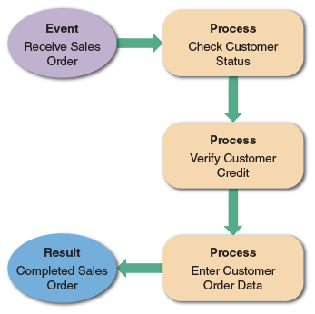
A rough sketch might be sufficient to document a simple business process. For complex models, analysts can choose computer-based tools that use business process modeling notation (BPMN). BPMN includes standard shapes and symbols to represent events, processes, workflows, and more. Multipurpose application such as Microsoft Visio or online diagramming tools such as draw.io can be used to create BPMN models. Notice that the draw.io model in Figure 1-8 uses BPMN symbols to represent the same sales order process shown in Figure 1-7.
Figure 1-8
This sample uses business process modeling notation (BPMN) to represent the same events, processes, and workflow shown in Figure 1-7.
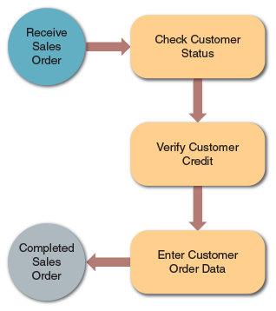
Source: Drawio.com
Systems developers often use multipurpose charting tools such as Lucidchart to display business-related models. Lucidchart is a popular tool that systems analysts can use to create business process diagrams, flowcharts, organization charts, network diagrams, floor plans, project timelines, and workflow diagrams, among others. Figure 1-9 shows how to drag and drop various symbols from the left pane into the drawing on the right and connect them to show a business process.
Figure 1-9
Lucidchart allows you to drag and drop various symbols and connect them to model a business process.
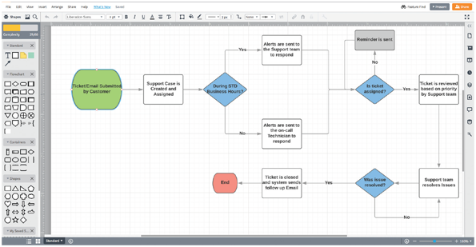
Source: Lucid Software Inc.
Go to pg.
help
Application Opened
Main content

1.5Business Information Systems
In the past, IT managers identified an information system based on its primary users. For example, administrative staff used office systems, operational people used operational systems, middle managers used decision support systems, and top managers used executive information systems.
Today, those traditional labels no longer apply. For example, all employees, including top managers, use office productivity systems to do their jobs. Similarly, operational users often require decision support systems to do their jobs. As business changes, information use also changes, and now it makes more sense to identify a system by its functions and features, rather than by its users. A new set of system definitions includes enterprise computing systems, transaction processing systems, business support systems, knowledge management systems, user productivity systems, digital assistants, and systems integration.
Go to pg.
help
Application Opened
Main content

1.5.1Enterprise Computing
Enterprise computing refers to information systems that support company-wide operations and data management requirements. Walmart’s inventory control system, Boeing’s production control system, and Hilton Hotels’ reservation system are examples of enterprise computing systems. The main objective of enterprise computing is to integrate a company’s primary functions (such as production, sales, services, inventory control, and accounting) to improve efficiency, reduce costs, and help managers make key decisions. Enterprise computing also improves data security and reliability by imposing a company-wide framework for data access and storage.
In many large companies, applications called enterprise resource planning (ERP) systems provide cost-effective support for users and managers throughout the company. For example, a car rental company can use ERP to forecast customer demand for rental cars at hundreds of locations. Because of its growth and potential, many hardware and software vendors target the enterprise computing market and offer a wide array of products and services. For example, Figure 1-10 highlights SAP’s leading ERP solutions. SAP is a Germany company that is a market leader in enterprise application software.
Figure 1-10
SAP is a leading vendor of ERP solutions that can boost productivity.
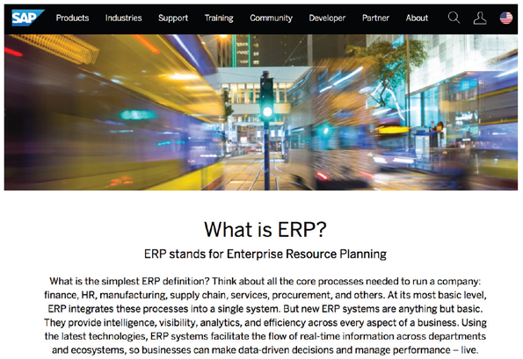
Source: SAP
By providing a company-wide computing environment, many firms have been able to achieve dramatic cost reductions. Other companies have been disappointed in the time, money, and commitment necessary to implement ERP successfully. A potential disadvantage is that ERP systems generally impose an overall structure that might or might not match the way a company operates. ERP is described in more detail in Chapter 7, which discusses development strategies.
Go to pg.
help
Application Opened
Main content

1.5.2Transaction Processing
Transaction processing (TP) systems process data generated by day-to-day business operations. Examples of TP systems include customer order processing, accounts receivable, and warranty claim processing.
TP systems perform a series of tasks whenever a specific transaction occurs. In the example shown in Figure 1-11, a TP system verifies the customer’s data, checks the customer’s credit status, checks the stock status, posts to accounts receivable, adjusts the inventory level, and updates the sales file. TP systems typically involve large amounts of data and are mission-critical systems because the enterprise cannot function without them.
Figure 1-11
A single sales transaction consists of six separate tasks, which the TP system processes as a group.
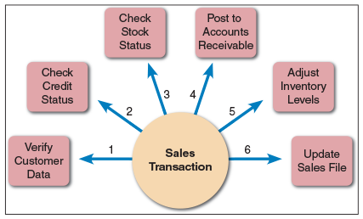
TP systems are efficient because they process a set of transaction-related commands as a group rather than individually. To protect data integrity, however, TP systems ensure that if any single element of a transaction fails, the system does not process the rest of the transaction.
Go to pg.
help
Application Opened
Main content

1.5.3Business Support
Business support systems provide job-related information support to users at all levels of a company. These systems can analyze transactional data, generate information needed to manage and control business processes, and provide information that leads to better decision making.
The earliest business computer systems replaced manual tasks, such as payroll processing. Companies soon realized that computers also could produce valuable information. The new systems were called management information systems (MIS) because managers were the primary users. Today, employees at all levels need information to perform their jobs, and they rely on information systems for that support.
A business support system can work hand in hand with a TP system. For example, when a company sells merchandise to a customer, a TP system records the sale, updates the customer’s balance, and makes a deduction from inventory. A related business support system highlights slow- or fast-moving items, customers with past-due balances, and inventory levels that need adjustment.
To compete effectively, firms must collect production, sales, and shipping data and update the company-wide business support system immediately. Automated data acquisition is possible using technology such as radio frequency identification (RFID), which uses high-frequency radio waves to track physical objects, such as the shirt shown in Figure 1-12. Major retailers such as Walmart, which requires its suppliers to add RFID tags to all items, have fueled RFID’s dramatic growth by tracking products throughout the retail process.
Figure 1-12
With an RFID tag, items can be tracked and monitored throughout the retail process.

Tatchaphol/ Shutterstock.com
An important feature of a business support system is decision support capability. Decision support helps users make decisions by creating a computer model and applying a set of variables. For example, a truck fleet dispatcher might run a series of what-if scenarios to determine the impact of increased shipments or bad weather. Alternatively, a retailer might use what-if analysis to determine the price it must charge to increase profits by a specific amount while volume and costs remain unchanged.
Go to pg.
help
Application Opened
Main content

1.5.4Knowledge Management
Knowledge management systems use a large database called a knowledge base that allows users to find information by entering keywords or questions in normal English phrases. A knowledge management system uses inference rules, which are logical rules that identify data patterns and relationships.
The WolframAlpha website, shown in Figure 1-13, describes itself as a “computational knowledge engine.” It has a sophisticated natural language front end that understands user queries in several domains. As shown in the figure, these domains include mathematics, science and technology, society and culture, and everyday life. WolframAlpha relies upon a large knowledge base spanning multiple websites and its own proprietary algorithms to provide users with detailed answers to their questions on many different topics. The results are displayed using a mix of multimedia, including mathematical equations if appropriate.
Figure 1-13
WolframAlpha describes itself as a “computational knowledge engine.”
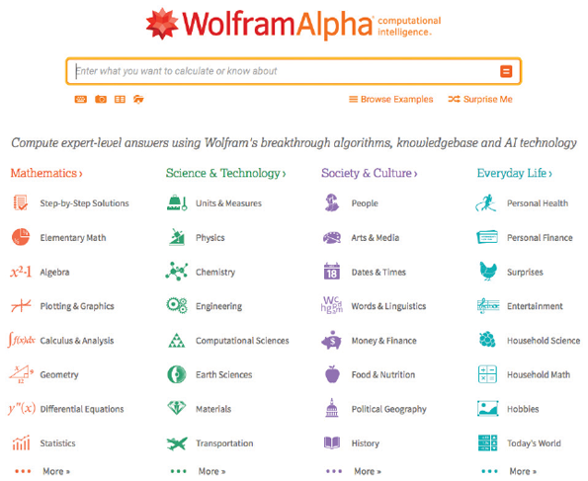
Source: Wolfram Alpha LLC
Go to pg.
help
Application Opened
Main content

1.5.5User Productivity
Companies provide employees at all levels with technology that improves productivity. Examples of user productivity systems include email, voice mail, video and web conferencing, word processing, automated calendars, database management, spreadsheets, desktop publishing, presentation graphics, company intranets, and integrated mobile computing systems. User productivity systems also include groupware, which enables users to share data, collaborate on projects, and work in teams. One popular groupware product is Slack, shown in Figure 1-14. Slack provides common app integration and unified communication channels for distributed teams.
Figure 1-14
Slack is a popular groupware application that provides common app integration and unified communication channels for distributed teams.
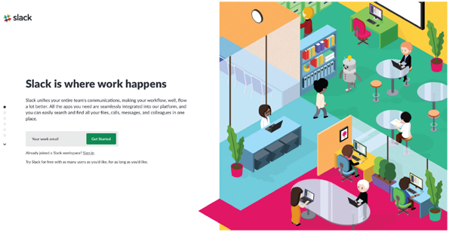
Source: Slack.com
When companies first installed word processing systems, managers expected to reduce the number of employees as office efficiency increased. That did not happen, primarily because the basic nature of clerical work changed. With computers performing the repetitive work, office personnel were able to handle tasks that required more judgment, decision making, and access to information.
Computer-based office work expanded rapidly as companies assigned more responsibility to employees at lower organizational levels. Relatively inexpensive hardware, powerful networks, corporate downsizing, and a move toward employee empowerment also contributed to this trend. Today, administrative assistants and company presidents alike are networked, use computer workstations, and share corporate data to perform their jobs.
Go to pg.
help
Application Opened
Main content

1.5.6Digital Assistants
Rapid advances in natural language processing have made a new type of business information system possible: the personal digital assistant. These systems are combinations of knowledge management systems and user productivity systems, enhanced with artificial intelligence and machine learning capabilities. They are typically cloud based and can be embedded in hardware devices of various sizes and types.
Digital assistants are exemplified by products such as Amazon.com’s Alexa, Apple’s Siri, and Google Assistant. Users speak to these applications just as they would speak to a real person. The device replies in a human-sounding voice. These services increase their capabilities over time. They can integrate with other software applications and actual hardware, such as controlling lights at home or the temperature at the office. An image of the Amazon Echo Dot, which is a smart speaker powered by Alexa, is shown in Figure 1-15.
Figure 1-15
Amazon.com’s Echo Dot, a digital assistant embedded in a smart speaker powered by Alexa.

Source: Amazon.com, Inc.
Go to pg.
help
Application Opened
Main content

1.5.7Systems Integration
Most large companies require systems that combine transaction processing, business support, knowledge management, and user productivity features. For example, suppose an international customer makes a warranty claim. A customer service representative enters the claim into a TP system, which updates two other systems: a knowledge management system that tracks product problems and warranty activity and a quality control system with decision support capabilities. A quality control engineer uses what-if analysis to determine if the firm should make product design changes to reduce warranty claims. In this example, a TP system is integrated with a knowledge management system and a business support system with decision support features.
Case in Point 1.2

Autonomous Vehicles
- Imagine you work for a large automotive company. Your manager asks you to look into integrating a digital assistant into a new vehicle for the next production year. How would understanding your company’s business profile help you complete this task?
Go to pg.
help
Application Opened
Main content

1.6Organizational Information Models
Corporate organizational structure has changed considerably in recent years. In an effort to increase productivity, many companies reduced the number of management levels and delegated responsibility to operational personnel. Although modern organization charts tend to be flatter, an organizational hierarchy still exists in most firms.
Go to pg.
help
Application Opened
Main content

1.6.1Functions and Organizational Levels
A typical organizational model identifies business functions and organizational levels, as shown in Figure 1-16. Within the functional areas, operational personnel report to supervisors and team leaders. The next level includes middle managers and knowledge workers, who, in turn, report to top managers. In a corporate structure, the top managers report to a board of directors elected by the company’s shareholders.
Figure 1-16
A typical organizational model identifies business functions and organizational levels.
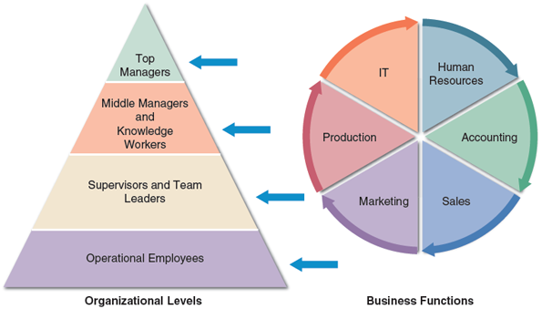
A systems analyst must understand the company’s organizational model to recognize who is responsible for specific processes and decisions and to be aware of what information is required by whom.
Go to pg.
help
Application Opened
Main content

1.6.2Top Managers
Top managers develop long-range plans, called strategic plans, which define the company’s overall mission and goals. To plot a future course, top managers ask questions such as “How much should the company invest in information technology?”, “How much will Internet sales grow in the next five years?”, or “Should the company build new factories or contract out production functions?”
Strategic planning affects the company’s future survival and growth, including long-term IT plans. Top managers focus on the overall business enterprise and use IT to set the company’s course and direction. To develop a strategic plan, top managers also need information from outside the company, such as economic forecasts, technology trends, competitive threats, and governmental issues.
Go to pg.
help
Application Opened
Main content

1.6.3Middle Managers and Knowledge Workers
Just below the top management level, most companies have a layer of middle managers and knowledge workers. Middle managers provide direction, necessary resources, and performance feedback to supervisors and team leaders. Because they focus on a somewhat shorter time frame, middle managers need more detailed information than top managers but somewhat less than supervisors who oversee day-to-day operations. For example, a middle manager might review a weekly sales summary for a three-state area, whereas a local sales team leader would need a daily report on customer sales at a single location.
In addition to middle managers, every company has people called knowledge workers. Knowledge workers include systems analysts, programmers, accountants, researchers, trainers, human resource specialists, and other professionals. Knowledge workers also use business support systems, knowledge management systems, and user productivity systems. Knowledge workers provide support for the organization’s basic functions. Just as a military unit requires logistical support, a successful company needs knowledge workers to carry out its mission.
Go to pg.
help
Application Opened
Main content

1.6.4Supervisors and Team Leaders
Supervisors, often called team leaders, oversee operational employees and carry out day-to-day functions. They coordinate operational tasks and people, make necessary decisions, and ensure that the right tools, materials, and training are available. Like other managers, supervisors and team leaders need decision support information, knowledge management systems, and user productivity systems to carry out their responsibilities.
Go to pg.
help
Application Opened
Main content

1.6.5Operational Employees
Operational employees include users who rely on transaction processing systems to enter and receive data they need to perform their jobs. In many companies, operational users also need information to handle tasks and make decisions that were assigned previously to supervisors. This trend, called empowerment, gives employees more responsibility and accountability. Many companies find that empowerment improves employee motivation and increases customer satisfaction.
Go to pg.
help
Application Opened
Main content

1.7Systems Development
Many options exist for developing information systems, but the most popular alternatives are structured analysis, which is a traditional method that still is widely used, object-oriented (O-O) analysis, which is a more recent approach that many analysts prefer, and agile methods, which include the latest trends in software development. Figure 1-17 provides an overview of the three methods, which are discussed in the following sections.
Figure 1-17
Comparison of structured, object-oriented, and agile development methods.
 | Structured Analysis | Object-Oriented Analysis | Agile Methods
Description | Represents the system in terms of data and the processes that act upon that data. System development is organized into phases, with deliverables and milestones to measure progress. The waterfall model typically consists of five phases: requirements, design, construction, testing, and maintenance & evolution. Iteration is possible among the phases. | Views the system in terms of objects that combine data and processes. The objects represent actual people, things, transactions, and events. Compared to structural analysis, O-O phases tend to be more interactive. Can use the waterfall model or a model that stresses greater iteration. | Stresses intense team-based effort. Breaks development into cycles, or iterations, that add functionality. Each cycle is designed, built, and tested in an ongoing process. Attempts to reduce major risks by incremental steps in short time intervals.
Modeling Tools | Data flow diagrams (DFDs) and process descriptions, which are described in Chapter 5. Also, business process modeling. | Various object-oriented diagrams depict system actors, methods, and messages, which are described in Chapter 6. Also, business process modeling. | Tools that enhance communication, such as collaborative software, brainstorming, and whiteborads. Business process modeling works well with agile methods.
Pros | Traditional method that has been very popular over time. Relies heavily on written documentation. Frequent phase iteration can provide flexibility comparable to other methods. Well-suited to traditional project management tools and techniques. | Integrates easily with object-oriented programming languages. Code is modular and reusable, which can reduce cost and development time. Easy to maintain and expand because new objects can be created using inherited properties. | Very flexible and efficient in dealing with change. Stresses team interaction and reflects a set of community-based values. Frequent deliverables constantly validate the project and reduce risk.
Cons | Changes can be costly, especially in later phases. Requirements are defined early, and can change during development. Users might not be able to describe their needs until they can see examples of features and functions. | Somewhat newer method might be less familiar to development team members. Interaction of objects and classes can be complex in larger systems. | Team members need a high level of technical and communications skills. Lack of structure and documentation can introduce risk factors. Overall project might be subject to scope change as user requirements change.
Although most projects utilize one approach, it is not unusual for systems developers to mix and match methods to gain a better perspective. In addition to these three main development methods, some organizations choose to develop their own in-house approaches or use techniques offered by software suppliers, tool vendors, or consultants. Many alternatives exist, and IT experts agree that no single development method is best in all cases. An approach that works well for one project might have disadvantages or risks in another situation. The important thing is to understand the various methods and the strengths and weaknesses of each approach.
Regardless of the development strategy, people, tasks, timetables, and costs must be managed effectively. Complex projects can involve dozens of people, hundreds of tasks, and many thousands of dollars. Project management is the process of planning, scheduling, monitoring, controlling, and reporting upon the development of an information system. Chapter 3 describes project management tools and techniques in detail.
Go to pg.
help
Application Opened
Main content

1.7.1Structured Analysis
Structured analysis is a traditional systems development technique that is time tested and easy to understand. Structured analysis uses a series of phases, called the systems development life cycle (SDLC), to plan, analyze, design, implement, and support an information system. Although structured analysis evolved many years ago, it remains a popular systems development method. Structured analysis is based on an overall plan, similar to a blueprint for constructing a building, so it is called a predictive approach.
Structured analysis uses a set of process models to describe a system graphically. Because it focuses on processes that transform data into useful information, structured analysis is called a process-centered technique. In addition to modeling the processes, structured analysis also addresses data organization and structure, relational database design, and user interface issues.
A process model shows the data that flows in and out of system processes. Inside each process, input data is transformed by business rules that generate the output. Figure 1-18 shows a process model that was created with the Visible Analyst CASE tool. The model, which represents a school registration system, is a called a data flow diagram (DFD) because it uses various symbols and shapes to represent data flow, processing, and storage. DFDs are discussed in more detail in Chapter 5.
Figure 1-18
This Visible Analyst screen shows a process model for a school registration system. The REGISTER STUDENTS process accepts input data from two sources and transforms it into output data.
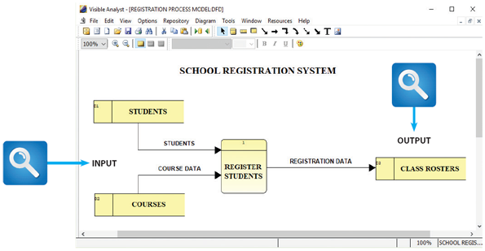
Source: Visible Systems Corporation
Structured analysis uses the SDLC to plan and manage the systems development process. The SDLC describes activities and functions that all systems developers perform, regardless of which approach they use. In the waterfall model, the result of each phase is called a deliverable, which flows into the next phase.
Some analysts see a disadvantage in the built-in structure of the SDLC because the waterfall model does not emphasize interactivity among the phases. This criticism can be valid if the SDLC phases are followed too rigidly. However, adjacent phases can and do interact, as shown by the circular arrows in Figure 1-19, and interaction among several phases is not uncommon. Used in this manner, the traditional model is not as different from agile methods as it might appear to be.
Figure 1-19
Development phases and deliverables are shown in the waterfall model. The circular symbols indicate interaction among the phases.
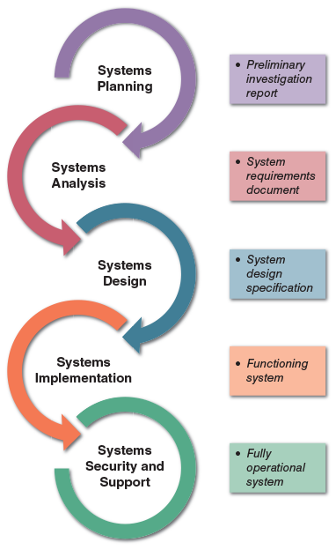
The SDLC model usually includes five steps, which are described in the following sections: systems planning, systems analysis, systems design, systems implementation, and systems support and security.

Systems Planning
The systems planning phase usually begins with a formal request to the IT department, called a systems request, which describes problems or desired changes in an information system or a business process. In many companies, IT systems planning is an integral part of overall business planning. When managers and users develop their business plans, they usually include IT requirements that generate systems requests. A systems request can come from a top manager, a planning team, a department head, or the IT department itself. The request can be very significant or relatively minor. A major request might involve a new information system or the upgrading of an existing system. In contrast, a minor request might ask for a new feature or a change to the user interface.
The purpose of this phase is to perform a preliminary investigation to evaluate an IT-related business opportunity or problem. The preliminary investigation is a critical step because the outcome will affect the entire development process. A key part of the preliminary investigation is a feasibility study that reviews anticipated costs and benefits and recommends a course of action based on operational, technical, economic, and time factors.
Suppose a systems analyst receives a request for a system change or improvement. The first step is to determine whether it makes sense to launch a preliminary investigation at all. Before a conclusion can be reached, more information about the business operations may be needed. After an investigation, the systems analyst might determine that the information system functions properly, but users need more training. In some situations, a business process review may be recommended rather than an IT solution. In other cases, a full-scale systems review may be necessary. If the development process continues, the next step is the systems analysis phase.

Systems Analysis
The purpose of the systems analysis phase is to build a logical model of the new system. The first step is requirements engineering, where the analyst investigates business processes and documents what the new system must do to satisfy users. Requirements engineering continues the investigation that began during the systems planning phase. To understand the system, fact-finding using techniques such as interviews, surveys, document review, observation, and sampling is performed. The fact-finding results are used to build business models, data and process models, and object models.
The deliverable for the systems analysis phase is the system requirements document. The system requirements document describes management and user requirements, costs, and benefits and outlines alternative development strategies.

Systems Design
The purpose of the systems design phase is to create a physical model that will satisfy all documented requirements for the system. At this stage, the user interface is designed, and necessary outputs, inputs, and processes are identified. In addition, internal and external controls are designed, including computer-based and manual features, to guarantee that the system will be reliable, accurate, maintainable, and secure. During the systems design phase, the application architecture is also determined, which programmers will use to transform the logical design into program modules and code.
The deliverable for this phase is the system design specification, which is presented to management and users for review and approval. Management and user involvement are critical to avoid any misunderstanding about what the new system will do, how it will do it, and what it will cost.

Systems Implementation
During the systems implementation phase, the new system is constructed. Whether the developers use structured analysis or O-O methods, the procedure is the same—programs are written, tested, and documented, and the system is installed. If the system was purchased as a package, systems analysts configure the software and perform any necessary modifications. The objective of the systems implementation phase is to deliver a completely functioning and documented information system. At the conclusion of this phase, the system is ready for use. Final preparations include converting data to the new system’s files, training users, and performing the actual transition to the new system.
The systems implementation phase also includes an assessment, called a systems evaluation, to determine whether the system operates properly and if costs and benefits are within expectations.

Systems Support and Security
During the systems support and security phase, the IT staff maintains, enhances, and protects the system. Maintenance changes correct errors and adapt to changes in the environment, such as new tax rates. Enhancements provide new features and benefits. The objective during this phase is to maximize return on the IT investment. Security controls safeguard the system from both external and internal threats. A well-designed system must be secure, reliable, maintainable, and scalable. A scalable design can expand to meet new business requirements and volumes. Information systems development is always a work in progress. Business processes change rapidly, and most information systems need to be updated significantly or replaced after several years of operation. For example, a web-based system may need more servers added to cope with increased workload.
Go to pg.
help
Application Opened
Main content

1.7.2Object-Oriented Analysis
Whereas structured analysis treats processes and data as separate components, object-oriented analysis combines data and the processes that act on the data as objects. Systems analysts use O-O to model real-world business processes and operations. The result is a set of software objects that represent actual people, things, transactions, and events. Using an O-O programming language, a programmer then writes the code that creates the objects.
An object is a member of a class, which is a collection of similar objects. Objects possess characteristics called properties, which the object inherits from its class or possesses on its own. As shown in Figure 1-20, the class called PERSON includes INSTRUCTOR and STUDENT. Because the PERSON class has a property called Address, a STUDENT inherits the Address property. A STUDENT also has a property called Major that is not shared by other members of the PERSON class.
Figure 1-20
The PERSON class includes INSTRUCTOR and STUDENT objects, which have inherited properties and their own properties.
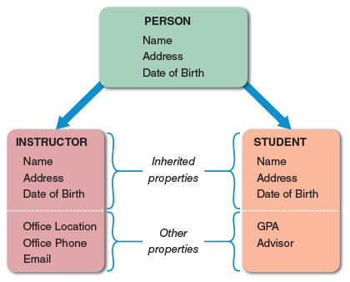
In O-O design, built-in processes called methods can change an object’s properties. For example, in an online catalog store, an ORDER object might have a property called STATUS that changes when a CUSTOMER object clicks to place, confirm, or cancel the order.
One object can send information to another object by using a message. A message requests specific behavior or information from another object. For example, an ORDER object might send a message to a CUSTOMER object that requests a shipping address. When it receives the message, the CUSTOMER object supplies the information. The ORDER object has the capability to send the message, and the CUSTOMER object knows what actions to perform when it receives the message. O-O analysis uses object models to represent data and behavior and to show how objects affect other objects. By describing the objects and methods needed to support a business operation, a systems developer can design reusable components that speed up system implementation and reduce development cost.
Object-oriented methods usually follow a series of analysis and design phases that are similar to the SDLC, although there is less agreement on the number of phases and their names. In an O-O model, the phases tend to be more interactive. Figure 1-21 shows an O-O development model where planning, analysis, and design tasks interact to produce prototypes that can be tested and implemented. The result is an interactive model that can accurately depict real-world business processes.
Figure 1-21
In a typical O-O development model, planning, analysis, and design tasks interact continuously to generate prototypes that can be tested.
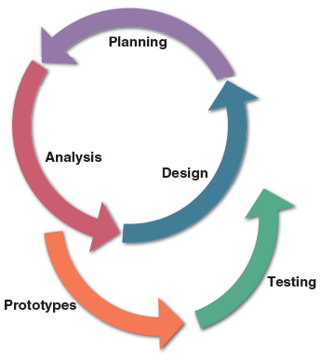
O-O methodology is popular because it provides an easy transition to O-O programming languages such as C++, Java, and Swift. Chapter 6 covers O-O analysis and design, with a detailed description of O-O terms, concepts, tools, and techniques.
Go to pg.
help
Application Opened
Main content

1.7.3Agile Methods
Development techniques change over time. For example, structured analysis is a traditional approach, and agile methods are the newest development. Structured analysis builds an overall plan for the information system, just as a contractor might use a blueprint for constructing a building. Agile methods, in contrast, attempt to develop a system incrementally by building a series of prototypes and constantly adjusting them to user requirements. As the agile process continues, developers revise, extend, and merge earlier versions into the final product. An agile approach emphasizes continuous feedback, and each incremental step is affected by what was learned in the prior steps.
Although relatively new to software development, the notion of iterative development can be traced back to Japanese auto firms that were able to boost productivity by using a flexible manufacturing system, where team-based effort and short-term milestones helped keep quality up and costs down. Agile methods have attracted a wide following and an entire community of users, as shown in Figure 1-22.
Figure 1-22
Scrum.org is a popular website supporting the agile community.
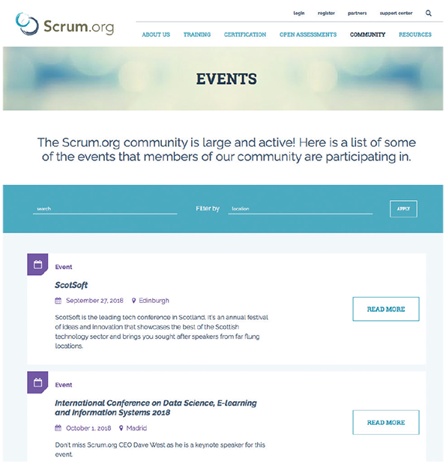
Source: Scrum.org
Agile methods typically use a spiral model, which represents a series of iterations, or revisions, based on user feedback. As the process continues, the final product gradually evolves. An agile approach requires intense interactivity between developers and individual users and does not begin with an overall objective. Instead, the agile process determines the end result. Proponents of the spiral model believe that this approach reduces risks and speeds up software development.
Barry Boehm, a noted software engineering professor, initially suggested spiral models in the 1990s. He stated that each iteration, or phase, of the model must have a specific goal that is accepted, rejected, or changed by the user or client. Thus, each iteration produces feedback and enhancements, which enable the team to reach the overall project goal. Typically, each iteration in a spiral model includes planning, risk analysis, engineering, and evaluation. The repeated iterations produce a series of prototypes, which evolve into the finished system. Notice that these phases resemble SDLC tasks, which also can be iterative.
Numerous other adaptive variations and related methods exist, and most IT developers expect this trend to continue in the future. Two examples are Scrum, which is discussed in Chapter 4, and Extreme Programming (XP), which is discussed in Chapter 11.
Although agile methods are becoming popular, analysts should recognize that these approaches have advantages and disadvantages. By their nature, agile methods can allow developers to be much more flexible and responsive but can be riskier than more traditional methods. For example, without a detailed set of system requirements, certain features requested by some users might not be consistent with the company’s larger game plan.
Other potential disadvantages of agile methods can include weak documentation, blurred lines of accountability, and too little emphasis on the larger business picture. Also, unless properly implemented, a long series of iterations might actually add to project cost and development time. The bottom line is that systems analysts should understand the pros and cons of any approach before selecting a development method for a specific project.
Go to pg.
help
Application Opened
Main content

1.7.4Prototyping
Structured analysis, object-oriented analysis, and agile methods can all employ prototyping as a supporting systems development method. Prototyping tests system concepts and provides an opportunity to examine input, output, and user interfaces before final decisions are made. A prototype is an early working version of an information system. Just as an aircraft manufacturer tests a new design in a wind tunnel, systems analysts construct and study information system prototypes. A prototype can serve as an initial model that is used as a benchmark to evaluate the finished system, or the prototype itself can develop into the final version of the system. Either way, prototyping speeds up the development process significantly.
A possible disadvantage of prototyping is that important decisions might be made too early, before business or IT issues are understood thoroughly. A prototype based on careful fact-finding and modeling techniques, however, can be an extremely valuable tool.
Go to pg.
help
Application Opened
Main content

1.7.5Tools
All systems development methods must be supported by tools to enable the systems analyst to develop, manage, and maintain large-scale information systems. These tools go by various names, including application lifecycle management (ALM), also called product lifecycle management (PLM); integrated development environments (IDE); and computer-aided systems engineering (CASE), also called computer-aided software engineering. CASE tools provide an overall framework for systems development and support a wide variety of design methodologies, including structured analysis and object-oriented analysis.
Tools make it easier to build an information system, thereby boosting IT productivity and improving the quality of the finished product. After developing a model, many CASE tools can generate program code, which speeds the implementation process. Figure 1-23 shows the website for Polarion, an ALM solution from Siemens that is part of their larger suite of offerings. Figure 1-24 shows the website for Microsoft Visual Studio, a leading IDE. Figure 1-25 shows the website for Cameo Systems Modeler, a leading MBSE CASE tool.
Figure 1-23
Polarion is a unified application lifecycle management (ALM) solution from Siemens.
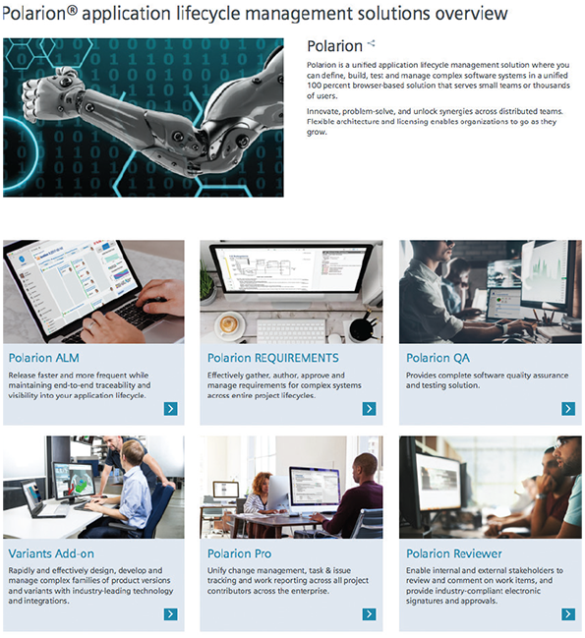
Source: Siemens Product Lifecycle Management Software Inc.
Figure 1-24
Microsoft Visual Studio is a fully-featured integrated development environment (IDE).
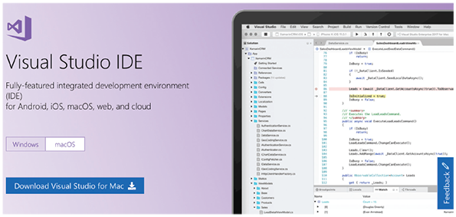
Source: Microsoft Corporation
Figure 1-25
Cameo Systems Modeler is a cross-platform collaborative Model-Based Systems Engineering (MBSE) environment.
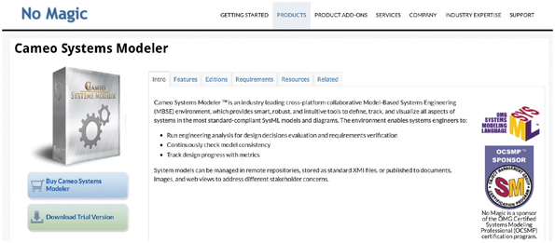
Source: No Magic, Inc.
Go to pg.
help
Application Opened
Main content

1.8The Information Technology Department
The IT department develops and maintains information systems. The IT group provides technical support, which includes seven main functions: application development, systems support and security, user support, database administration, network administration, web support, and quality assurance. These functions overlap considerably and often have different names in different companies.
The structure of the IT department varies among companies, as does its name and placement within the organization. In a small firm, one person might handle all computer support activities and services, whereas a large corporation might require many people with specialized skills to provide information systems support. Figure 1-26 shows a typical IT organization in a company that has networked PCs, enterprise-wide databases, centralized processing, and web-based operations.
Figure 1-26
Depending on its size, an IT department might have separate organization units for these functions, or they might be combined into a smaller number of teams.
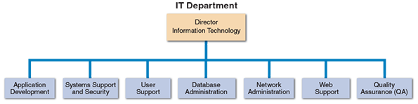
Go to pg.
help
Application Opened
Main content

1.8.1Application Development
The IT application development group typically provides leadership and overall guidance, but teams consisting of users, managers, and IT staff members develop the systems themselves. A popular model for information systems development is a project-oriented team with IT professionals providing overall coordination, guidance, and technical support.
Case in Point 1.3

Global Hotels and Momma’s Motels
- Suppose you work in the IT department of Global Hotels, a multinational hotel chain. Global Hotels runs several specialized business support systems, including a guest reservations system that was developed in-house to meet the requirements of a large company with worldwide operations. Guests can make one-stop online reservations by visiting Global’s website, which has links to all major travel industry sites.
Global Hotels just acquired Momma’s, a regional chain of 20 motels. Momma’s uses a vertical reservations package suitable for small- to medium-sized businesses and a generic accounting and finance package. Should Momma’s use Global Hotels’ information systems or continue with its own? In your answer, consider issues such as business profiles, business processes, system interactivity, and e-commerce. What additional information would be helpful to you in making a recommendation?
Go to pg.
help
Application Opened
Main content

1.8.2Systems Support and Security
Systems support and security provides vital protection and maintenance services for system hardware and software, including enterprise computing systems, networks, transaction processing systems, and corporate IT infrastructure. The systems support and security group implements and monitors physical and electronic security hardware, software, and procedures. This group also installs and supports operating systems, telecommunications software, and centralized database management systems. In addition, systems support and security technicians provide technical assistance to other groups in the IT department. If a site has a large number of remote clients, the systems support group often includes a deployment team that installs and configures the workstations.
Go to pg.
help
Application Opened
Main content

1.8.3User Support
User support provides users with technical information, training, and productivity support. The user support function usually is called a help desk. A help desk’s staff trains users and managers on application software such as email, word processing, spreadsheets, and graphics packages. User support specialists answer questions, troubleshoot problems, and serve as a clearinghouse for user problems and solutions.
Go to pg.
help
Application Opened
Main content

1.8.4Database Administration
Database administration involves data design, management, security, backup, and access. In small- and medium-sized companies, an IT support person performs those roles in addition to other duties. Regardless of company size, mission-critical database applications require continuous attention and technical support.
Go to pg.
help
Application Opened
Main content

1.8.5Network Administration
Business operations depend on networks that enable company-wide information systems. Network administration includes hardware and software maintenance, support, and security. In addition to controlling user access, network administrators install, configure, manage, monitor, and maintain network applications. Network administration is discussed in more detail in Chapter 10.
Go to pg.
help
Application Opened
Main content

1.8.6Web Support
Web support is a vital technical support function. Web support specialists design and construct web pages, monitor traffic, manage hardware and software, and link web-based applications to the company’s information systems. Reliable, high-quality web support is especially critical for companies engaged in e-commerce.
Go to pg.
help
Application Opened
Main content

1.8.7Quality Assurance (QA)
Many large IT departments also use a quality assurance (QA) team that reviews and tests all applications and systems changes to verify specifications and software quality standards. The QA team usually is a separate unit that reports directly to IT management.
Go to pg.
help
Application Opened
Main content

1.9The Systems Analyst
A systems analyst investigates, analyzes, designs, develops, installs, evaluates, and maintains a company’s information systems. To perform those tasks, a systems analyst constantly interacts with users and managers within and outside the company. The following sections describe a systems analyst’s role, knowledge, skills, education, certifications, and career opportunities.
Go to pg.
help
Application Opened
Main content

1.9.1Role
A systems analyst helps develop IT systems that support business requirements. To succeed, analysts often must act as translators. For example, when they describe business processes to programmers, they must speak a language that programmers will understand clearly. Typically, the analyst builds a series of models, diagrams, and decision tables and uses other descriptive tools and techniques. Similarly, when communicating with managers, the analyst often must translate complex technical issues into words and images that nontechnical people can grasp. To do this, the analyst uses various presentation skills, models, and communication methods.
Analysts are often the company’s best line of defense against an IT disaster—a system that is technically sound but fails because it does not meet the needs of users and managers. When this occurs, poor communication is usually to blame. For an analyst, the most valuable skill is the ability to listen. An effective analyst will involve users in every step of the development process and listen carefully to what they have to say. As the process continues, the analyst will seek feedback and comments from the users. This input can provide a valuable early warning system for projects that might otherwise go off the track.
Go to pg.
help
Application Opened
Main content

1.9.2Knowledge, Skills, and Education
A successful systems analyst needs technical knowledge, oral and written communication skills, an understanding of business operations, and critical thinking skills. Educational requirements vary widely depending on the company and the position. In a rapidly changing IT marketplace, a systems analyst must manage his or her own career and have a plan for professional development.

Technical Knowledge
State-of-the-art knowledge is extremely important in a rapidly changing business and technical environment. The Internet offers numerous opportunities to update technical knowledge and skills. Many IT professionals go online to learn about technical developments, exchange experiences, and get answers to questions. For example, the International Council on Systems Engineering (INCOSE), shown in Figure 1-27, is one of the leading organizations offering systems analysts a wealth of information, news, training, support communities, and more. Analysts also maintain their skills by attending training courses, both on-site and online. Networking with colleagues is another way to keep up with new developments, and membership in professional associations also is important.
Figure 1-27
INCOSE is one of the leading organizations offering systems analysts a wealth of information, news, training, communities, and more.
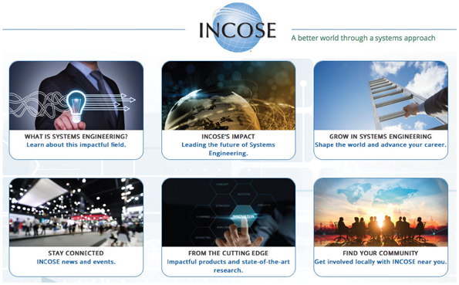
Source: INCOSE - International Council on Systems Engineering

Communication Skills
A systems analyst needs strong oral and written communication skills and the ability to interact with people at all levels, from operational staff to senior executives. Often, the analyst must work with people outside the company, such as software and hardware vendors, customers, and government officials. Analysts often coordinate IT project teams, where they use communication skills to guide and motivate team members.

Business Skills
A systems analyst works closely with managers, supervisors, and operational employees. To be effective, he or she must understand business operations and processes, communicate clearly, and translate business needs into requirements that can be understood by programmers and systems developers. A successful analyst is business-oriented, curious, comfortable with financial tools, and able to see the big picture. Chapter 2 describes some basic concepts, including strategic planning, SWOT analysis, and feasibility tests.

Critical Thinking Skills
Most educators agree that critical thinking skills include the ability to compare, classify, evaluate, recognize patterns, analyze cause and effect, and apply logic. Critical thinkers often use a what-if approach, and they have the ability to evaluate their own thinking and reasoning.
Critical thinking skills are valuable in the IT industry, where employers seek job candidates who can demonstrate these skills and bring them to the workplace. Figure 1-28 shows the website for Critical Thinking Community, a nonprofit organization that provides encouragement and resources for critical thinkers.
Figure 1-28
The Critical Thinking Community is a nonprofit organization that provides encouragement and resources for critical thinkers.
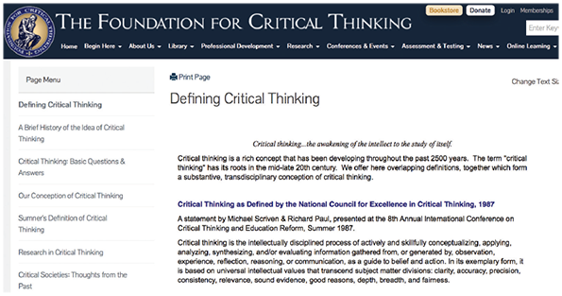
Source: Foundation for Critical Thinking

Education
Companies typically require systems analysts to have a college degree in information systems, computer science, or business, and some IT experience usually is required. For higher-level positions, many companies require an advanced degree. Sometimes, educational requirements can be waived if a candidate has significant experience, skills, or professional certifications.
Go to pg.
help
Application Opened
Main content

1.9.3Certification
Many hardware and software companies offer certification for IT professionals. Certification verifies that an individual demonstrated a certain level of knowledge and skill on a standardized test. Certification is an excellent way for IT professionals to learn new skills and gain recognition for their efforts. Although certification does not guarantee competence or ability, many companies regard certification as an important credential for hiring or promotion. Certification is discussed in more detail in Chapter 12.
In addition to traditional hardware and software certifications, some firms are exploring ways to assess critical thinking skills, as shown in Figure 1-29. These skills include perception, organization, analysis, problem solving, and decision making. Whether or not formal certification is involved, these skills are extremely valuable to IT professionals and the employers who hire them.
Figure 1-29
Employers like to hire people who can think logically and effectively.
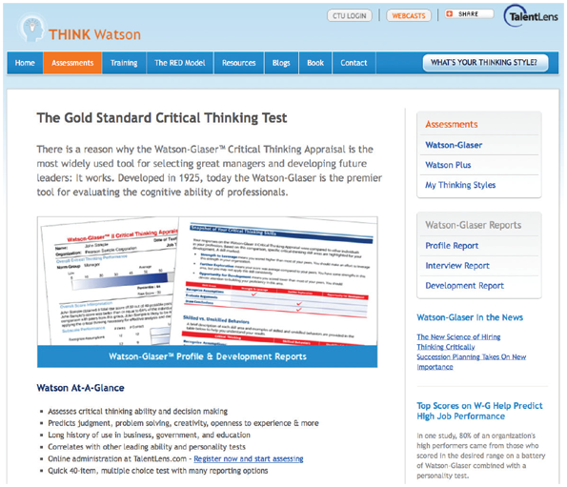
Source: Pearson Education
Go to pg.
help
Application Opened
Main content

1.9.4Career Opportunities
The demand for systems analysts is expected to remain strong. Companies will need systems analysts to apply new information technology, and the explosion in e-commerce will fuel IT job growth. The systems analyst position is a challenging and rewarding one that can lead to a top management position. With an understanding of technical and business issues, a systems analyst has an unlimited horizon. Many companies have presidents and senior managers who started in IT departments as systems analysts.
The responsibilities of a systems analyst at a small firm are different from those at a large corporation. Working at a small or large company is a matter of personal choice.

Job Titles
First, do not rely on job titles alone. Some positions are called systems analysts but involve only programming or technical support. In other cases, systems analyst responsibilities are found in positions titled computer specialist, programmer, programmer/analyst, systems designer, software engineer, and various others. Be sure the responsibilities of the job are stated clearly when considering a position.

Company Organization
Find out everything about the company and where the IT department fits in the organization chart: Where are IT functions performed, and by whom? A firm might have a central IT group but decentralize the systems development function. This situation sometimes occurs in large conglomerates, where the parent company consolidates information that actually is developed and managed at the subsidiary level.

Company Size
A smaller firm might provide more variety. However, a larger company with state-of-the-art systems provides opportunities for specialization. Although there might be more responsibility in a smaller company, the promotional opportunities and financial rewards could be greater in larger companies. Working as an independent consultant is also an option. Many consulting firms have been successful in offering their services to smaller business enterprises that do not have the expertise to handle systems development on their own.

Salary, Location, and Future Growth
Finally, consider salary, location, and the company’s prospects for future growth and success. Initial impressions from employment interviews with the company and its people are important. Most importantly, review short- and long-term goals very carefully before deciding which position is most suitable.

Corporate Culture
In addition to having goals, methods, and information systems requirements, every firm has an underlying corporate culture. A corporate culture is the set of beliefs, rules, traditions, values, and attitudes that define a company and influence its way of doing business. To be successful, a systems analyst must understand the corporate culture and how it affects the way information is managed. Companies sometimes include statements about corporate culture in their mission statements, which are explained in Chapter 2.
A systems analyst must understand the firm’s culture and find it comfortable. If the company encourages personal growth and empowerment, work is much more enjoyable. For example, consider the Salesforce corporate culture described in Figure 1-30. A company like Salesforce is likely to attract, retain, and motivate the best and brightest people. In fact, Salesforce ranked #1 in Fortune’s 21st annual list of the country’s greatest places to work.
Figure 1-30
A corporate culture like Salesforce is likely to attract, retain, and motivate the best and brightest people.
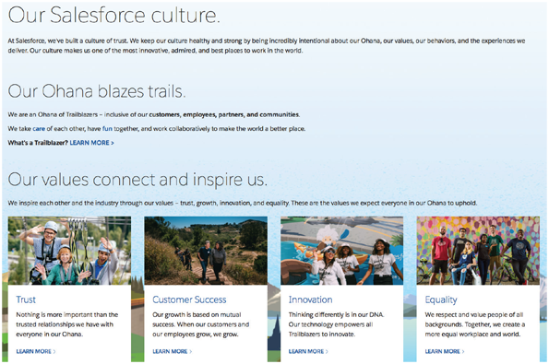
Source: salesforce.com, inc.
Go to pg.
help
Application Opened
Main content

1.9.5Trends in Information Technology
Systems analysts need to track trends in information technology because technological changes affect business operations, career opportunities, and enterprise strategies. Very few areas evolve as fast as information technology. Each year sees evolutionary developments in current technology, such as faster processors, wider network bandwidth, and increased storage capabilities. Once in a while, a truly transformative change occurs, such as the injection of artificial intelligence applications across the enterprise or a revolution in the basic tenets of computation with the nascent introduction of quantum computing.
Some of the key trends that are disrupting information technology include agile methods, artificial cloud computing, data science, mobile devices, service orientation, and social media networks. These trends can affect education and training needs, give rise to new certifications, and open lucrative career opportunities.
Agile methods have already been discussed in this chapter and are covered in more detail later in the book. The agile movement is a significant trend in information technology that all systems analysts should follow. It started as a response to the heavyweight process models and was initially used for smaller teams, but interest in agile methods has grown to encompass almost all application areas and business organizations.
Cloud computing is in many ways a return to the past: a model of shared computing and data storage resources accessed from remote clients, rather like the mainframe era. However, cloud computing is different in that it offers virtualized resources that can grow to accommodate increased requirements as needed. It’s also different in that buying capacity on demand from a thriving vendor marketplace can reduce the capital costs needed for in-house computing infrastructure. It also presents additional security needs to address.
If cloud computing represents the computational aspect of processing, data science represents the data aspect. The world is producing more and more data at an incredible rate. New tools and techniques are being developed to manage these large datasets. Areas such as machine learning and predictive analytics are experiencing tremendous growth as companies try to apply artificial intelligence techniques to the problem of big data. As depicted in Figure 1-31, many of the developments related to big data are driving trends in information technology—trends the systems analyst must follow to stay current.
Figure 1-31
Big data is driving many new developments in information technology.
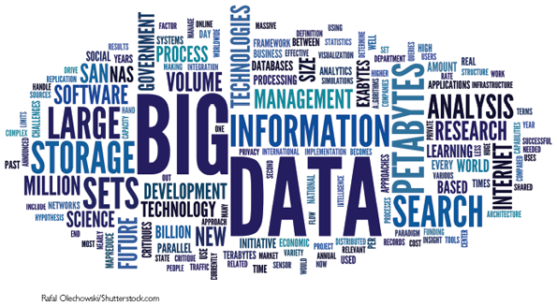
Rafal Olechowski/ Shutterstock.com
Mobile devices and the app ecosystem that goes with them are a revolutionary development in information technology. The shift of computing capabilities to “the edge” of the network has put unprecedented power in the hands of end users. Smartphones are the most common computing device on the planet, and systems analysts will need to know about the role of apps and the effect of the bring your own device (BYOD) movement in the enterprise.
Traditionally, IT companies were identified as product-oriented or service-oriented. Product-oriented firms manufactured computers, routers, or microchips, while service-oriented companies included consultants, vendors, software developers, and service providers. Today, those distinctions are gone. Most successful IT companies offer a mix of products, services, and support. Value-added services such as consulting, software, and technical support often are more profitable than hardware sales.
Social media rides on some of the trends mentioned earlier, such as cloud computing, data science, mobile devices, and service orientation. However, social media has had arguably the most profound influence on society. Witness the popularity of Facebook, with over 2 billion users worldwide. Companies tap into the power of social media, coupled with location-aware apps, to create truly innovative solutions that are changing the face of information technology.

A Question of Ethics
- iStock.com/faberfoto_itYou are enjoying your job as a summer intern in the IT department of a local company. At lunch yesterday, several people were discussing ethical issues. You learned that some of them belong to IT organizations that have ethical codes to guide members and set professional standards. For example, your supervisor belongs to the Association for Computing Machinery (ACM), which has over 100,000 members from more than 100 countries and a website at acm.org. Your supervisor said that the ACM code of ethics is important to her and would definitely influence her views. On the other hand, one of the senior programmers believes that his own personal standards would be sufficient to guide him if ethical questions were to arise.
Because you are excited about your career as an IT professional, you decide to visit ACM’s website to examine the code of ethics and make up your own mind. After you do so, would you tend to agree more with your supervisor or with the senior programmer?
Go to pg.
help
Application Opened
Main content

1.10Summary
Information technology (IT) refers to the combination of hardware, software, and services that people use to manage, communicate, and share information. Technology is changing rapidly, and IT professionals must prepare for the future. IT supports business operations, improves productivity, and helps managers make decisions. Systems analysis and design is the process of developing information systems that transform data into useful information, and systems analysts are IT team members who help plan, develop, and maintain information systems.
The essential components of an information system are hardware, software, data, processes, and people. Hardware consists of everything in the physical layer of the information system. Software consists of system software, which manages the hardware components, and application software, which supports day-to-day business operations. Data is the raw material that an information system transforms into useful information. Processes describe the tasks and functions that users, managers, and IT staff members perform. People who interact with a system include users, from both within and outside the company.
Most successful companies offer a mix of products, technical and financial services, consulting, and customer support. A rapidly growing business category is the Internet-dependent firm, which relies solely on Internet-based operations. E-commerce includes business-to-consumer (B2C) sales, and business-to-business (B2B) transactions that use Internet-based digital marketplaces or private electronic data interchange (EDI) systems.
A systems analyst starts with a business profile, which is an overview of company functions, and then he or she creates a series of business models that represent business processes, which describe specific transactions, events, tasks, and results. Analysts use business process modeling tools to document complex operations. Systems analysts use modeling, prototyping, and computer-aided systems engineering (CASE) tools. Modeling produces a graphical representation of a concept or process, whereas prototyping involves the creation of an early working model of the information or its components.
Based on their functions and features, business information systems are identified as enterprise computing systems, transaction processing systems, business support systems, knowledge management systems, user productivity systems, digital assistants, or systems integration. In most companies, significant overlap and integration exists among the various types of information systems.
A typical organization structure includes top managers, middle managers and knowledge workers, supervisors and team leaders, and operational employees. Top managers develop strategic plans, which define an overall mission and goals. Middle managers provide direction, resources, and feedback to supervisors and team leaders. Knowledge workers include various professionals who function as support staff. Supervisors and team leaders oversee operational employees. Each organizational level has a different set of responsibilities and information needs.
Three popular system development approaches are structured analysis, which is a traditional method that still is widely used, object-oriented analysis (O-O), which is a more recent approach that many analysts prefer, and agile methods, which include the latest trends in software development.
Structured analysis uses a series of phases, called the systems development life cycle (SDLC) that usually is shown as a waterfall model. Structured analysis uses an overall plan, similar to a blueprint for constructing a building, so it is called a predictive approach. This method uses a set of process models to describe a system graphically and also addresses data organization and structure, relational database design, and user interface issues.
Object-oriented analysis combines data and the processes that act on the data into things called objects that represent people, things, transactions, and events. Objects have characteristics, called properties, and built-in processes, called methods, and can send information to other objects by using messages. Using an O-O programming language, a programmer then writes the code that creates the objects. Object-oriented methods usually follow a series of analysis and design phases similar to the SDLC, but the phases are more interactive.
Agile methods are the newest development approach and attempt to develop a system incrementally by building a series of prototypes and constantly adjusting them to user requirements. Agile methods typically use a spiral model, which represents a series of iterations, or revisions, based on user feedback. The repeated iterations produce a series of prototypes, which evolve into the finished system.
Regardless of the development strategy, people, tasks, timetables, and costs must be managed effectively using project management tools and techniques, which are described in detail in Chapter 3.
The IT department develops, maintains, and operates a company’s information systems. IT staff members provide technical support, including application development, systems support, user support, database administration, network administration, web support, and quality assurance. These functions overlap considerably and often have different names in different companies.
In addition to technical knowledge, a systems analyst must understand the business, think critically, and communicate effectively. Valuable credentials such as certifications are available to systems analysts. A systems analyst’s responsibilities depend on a company’s organization, size, and culture. Systems analysts need to consider salary, location, and future growth potential when making a career decision.
Some of the key trends in information technology include agile methods, artificial cloud computing, data science, mobile devices, service orientation, and social media networks.
Go to pg.
help
Application Opened
Main content

Chapter Review

Key Terms
- agile methods
- app
- application lifecycle management (ALM)
- application software
- artificial intelligence
- B2B (business-to-business)
- B2C (business-to-consumer)
- big data
- bring your own device (BYOD)
- business model
- business process
- business process model (BPM)
- business process modeling notation (BPMN)
- business profile
- business rules
- business support systems
- CASE tools
- certification
- class
- computer-aided software engineering
- computer-aided systems engineering (CASE)
- corporate culture
- critical thinking skills
- data
- data center
- data flow diagram (DFD)
- data science
- deliverable
- e-commerce (electronic commerce)
- electronic data interchange (EDI)
- empowerment
- enterprise applications
- enterprise computing
- enterprise resource planning (ERP)
- feasibility study
- groupware
- hardware
- help desk
- horizontal system
- inference rules
- information
- information system
- information technology (IT)
- integrated development environments (IDE)
- iterative
- knowledge base
- legacy systems
- machine learning
- management information systems (MIS)
- mission-critical system
- model-based systems engineering (MBSE)
- modeling
- Moore’s law
- NoSQL databases
- objects
- object-oriented (O-O) analysis
- personal digital assistant
- preliminary investigation
- processes
- product lifecycle management (PLM)
- product-oriented
- Project management
- properties
- prototype
- radio frequency identification (RFID)
- requirements engineering
- scalable
- service-oriented
- software
- spiral model
- stakeholders
- strategic plans
- structured analysis
- supply chain
- supply chain management (SCM)
- system
- system design specification
- system requirements document
- system software
- systems analysis and design
- systems analysis phase
- systems analyst
- systems design phase
- systems development life cycle (SDLC)
- systems implementation phase
- systems planning phase
- systems request
- systems support and security phase
- technical support
- transaction processing (TP) systems
- user productivity systems
- users
- vertical system
- waterfall model
Go to pg.
help

